REPORT ON WEB DEVELOPMENT –TEARM 1

CSY1018

NAAYA AAYAM MULTI-DISCIPLINARY INSTITUTE (NAMI)

UNIVERSITY OF NORTHAMPTON

SUBMITTED BY

NAME: ISHAN ACHARYA

UN ID: 17437366

Table of content:

1. Getting started
2. Designs
   1. Wireframes
      1. Wireframe of homepage
      2. Wireframe of homepage(responsive)
      3. Wireframe for bio page
      4. Wireframe for bio page(responsive)
      5. Wireframe for contact page
      6. Wireframe for contact page(responsive)
      7. Wireframe for cv page
      8. Wireframe for cv page(responsive)
3. Final designs
   1. Homepage
   2. Homepage(responsive)
   3. Bio page
   4. Bio page(responsive)
   5. Contact page
   6. Contact page(responsive)
   7. Cv page
   8. Cv page(responsive)
4. Working progress
5. Good practice
   1. Speed test
   2. Validation test
   3. Social links
6. Conclusion
7. References
8. Getting started

In the beginning I did have a design in my mind for the webpage that I was going to make but I wanted it to be better so I visited different websites for ideas, designs and color combination, I also looked for different Html and css codes in order to make my webpage more attractive as we are not allowed to use javascript and bootstarp. So to make my work easier I started making wireframes for my design.

1. Designs
   1. Wireframes
      1. Wireframe for homepage

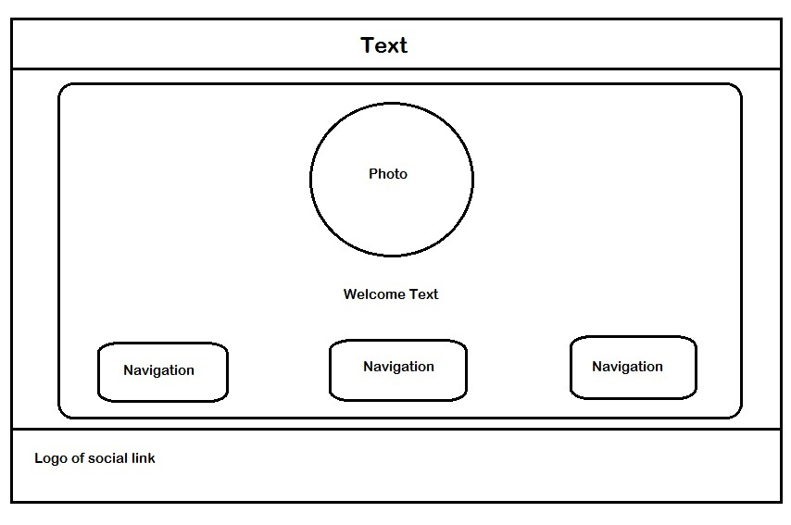

* + 1. Wireframe for homepage(responsive)

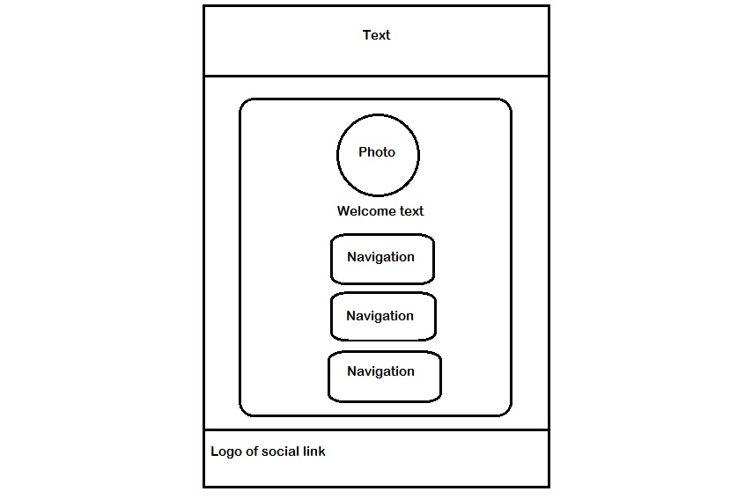

* + 1. Wireframe for bio page

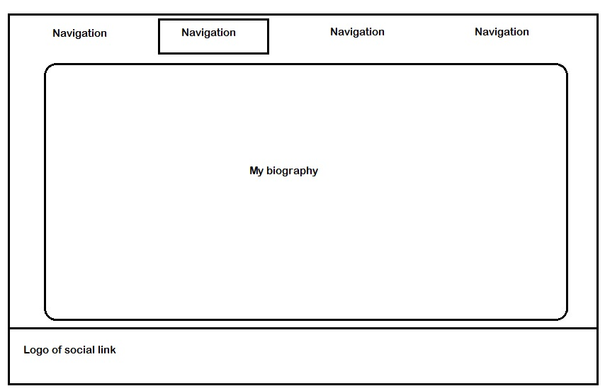

* + 1. Wireframe for bio page(responsive)

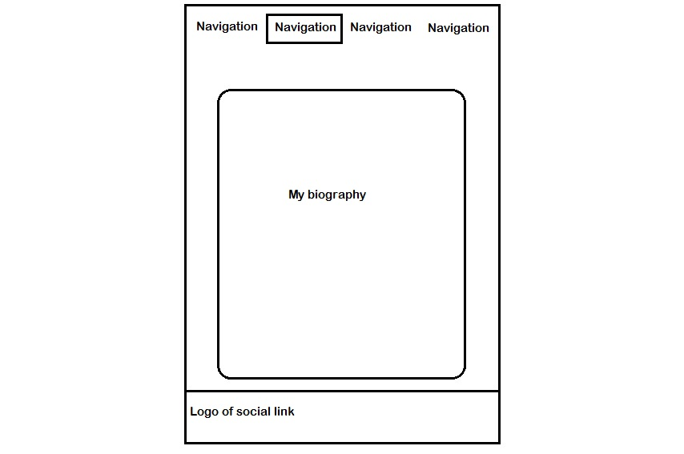

* + 1. Wireframe for contact page

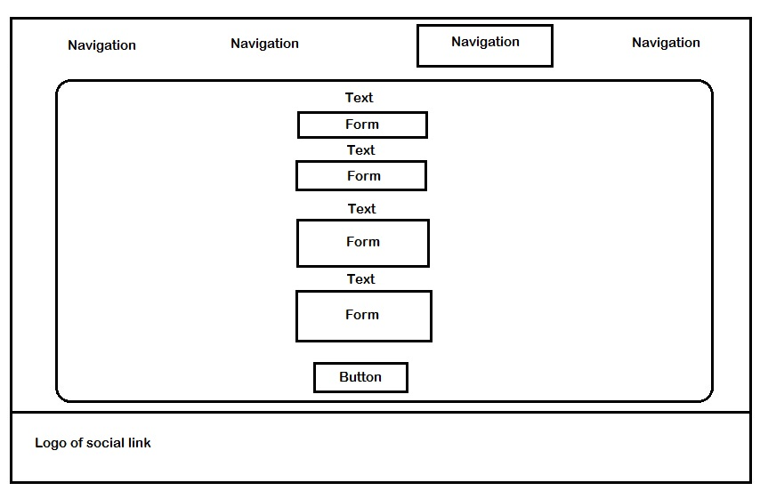

* + 1. Wireframe for contact page(responsive)

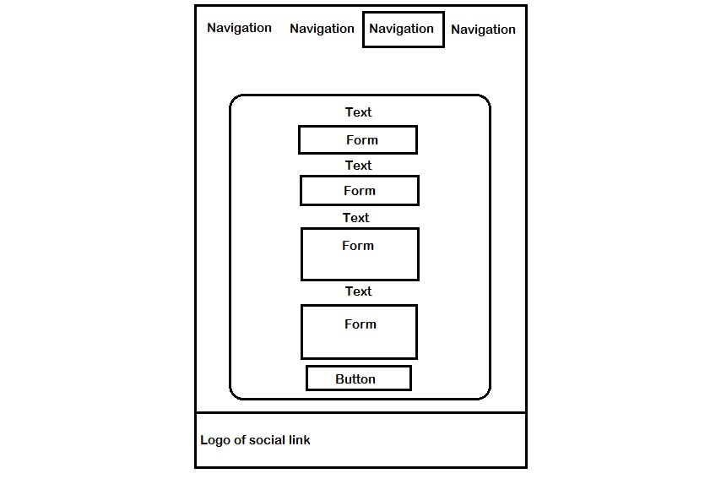

* + 1. Wireframe for cv page

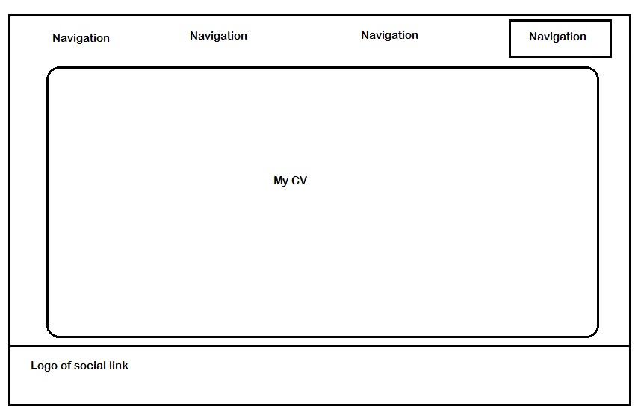

* + 1. Wireframe for cv page(responsive)

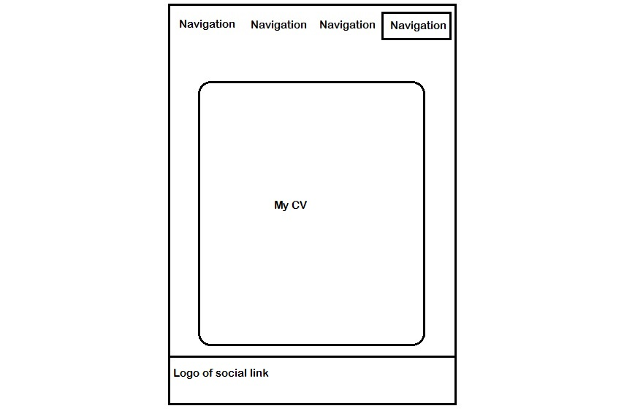

1. Final design
   1. Homepage

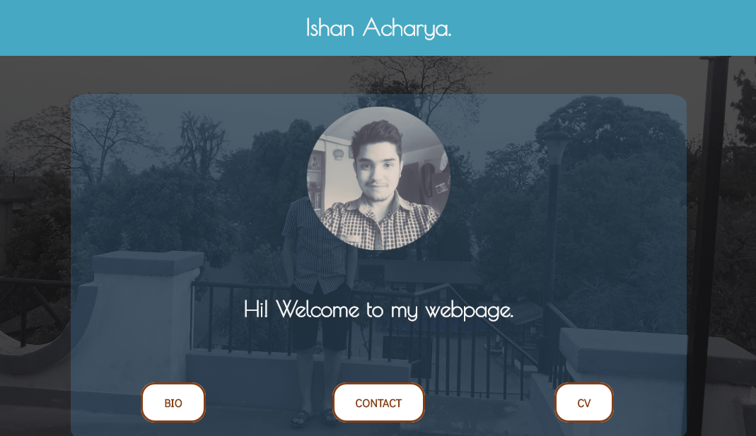

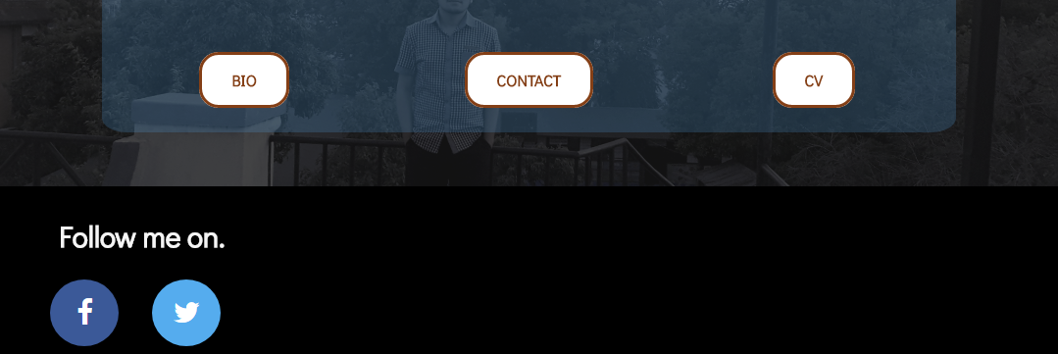

* 1. Homepage responsive

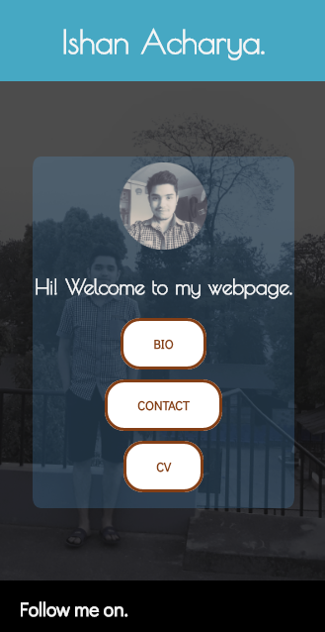

* 1. Bio page

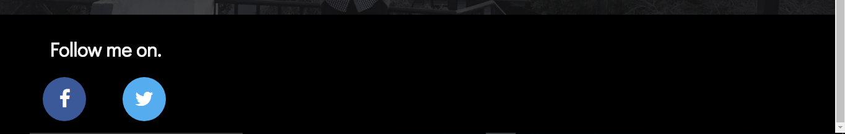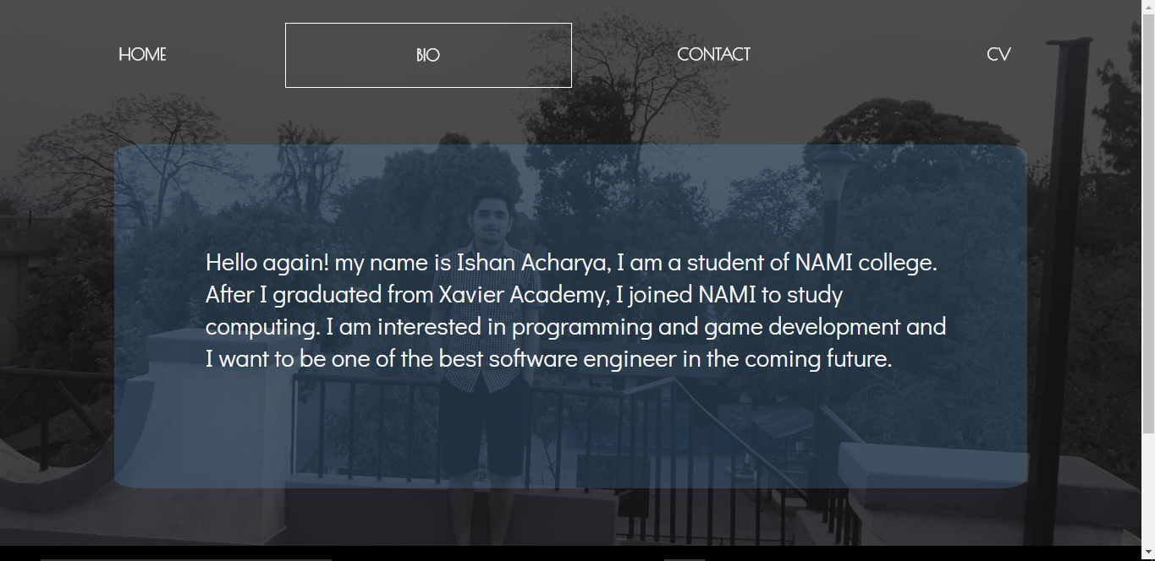

* 1. Bio page (responsive)

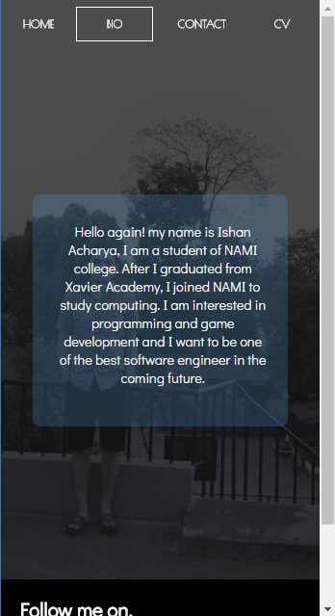



* 1. Contact page

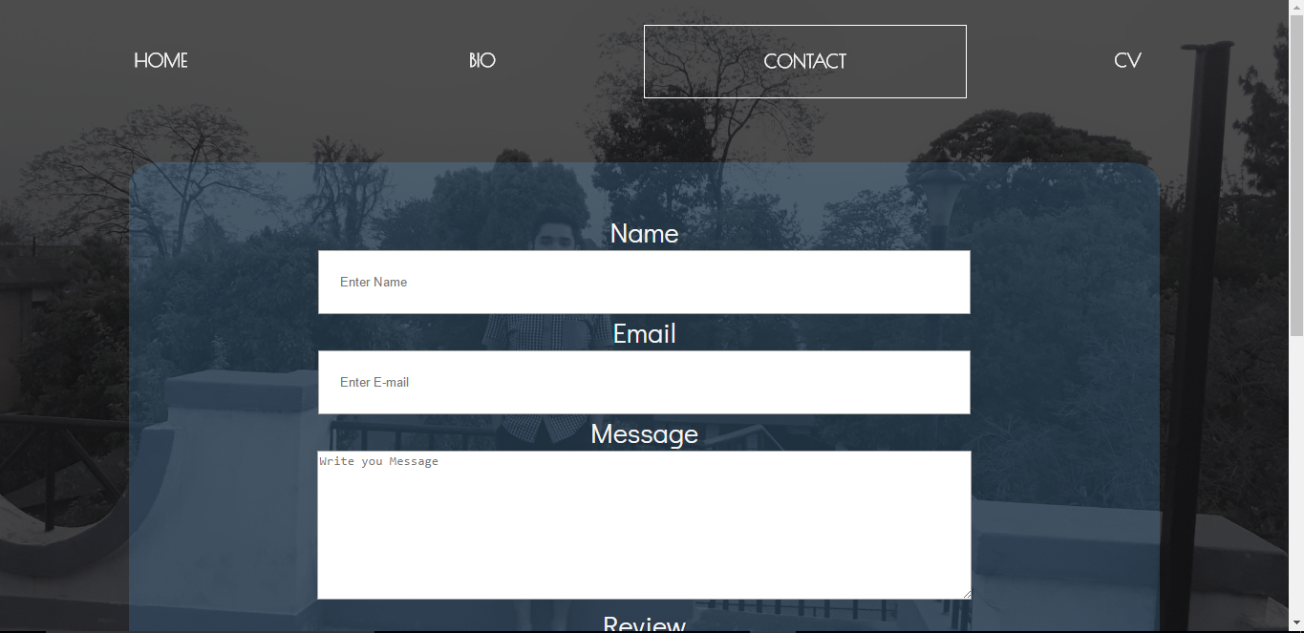

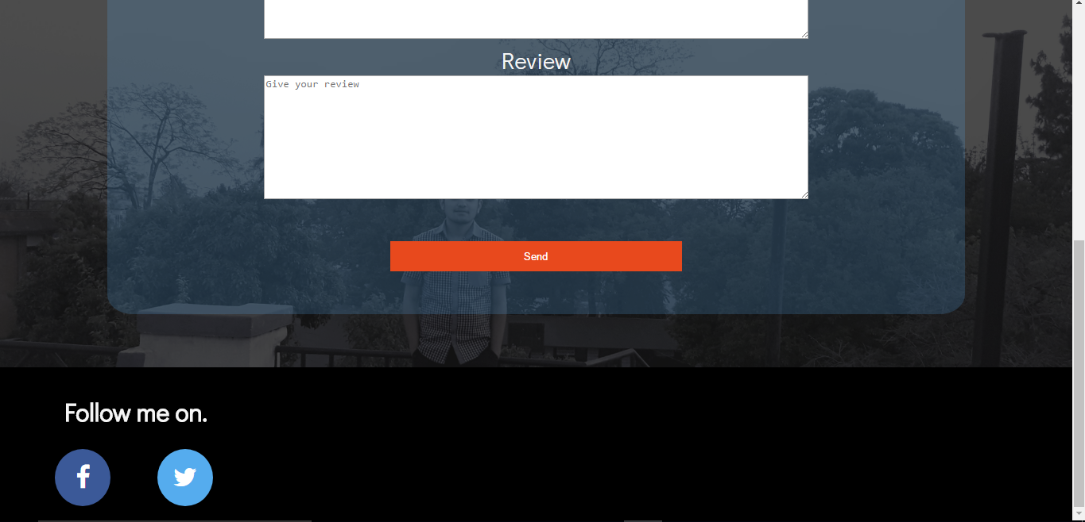

* 1. Contact page(responsive)

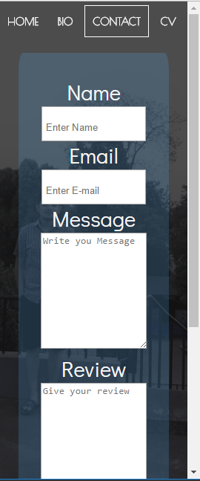

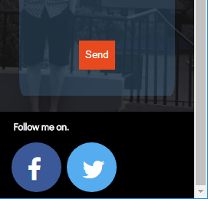

* 1. Cv page

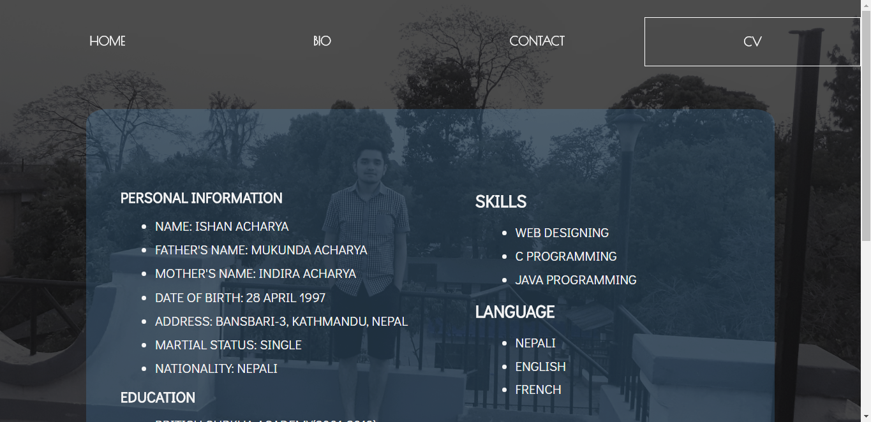

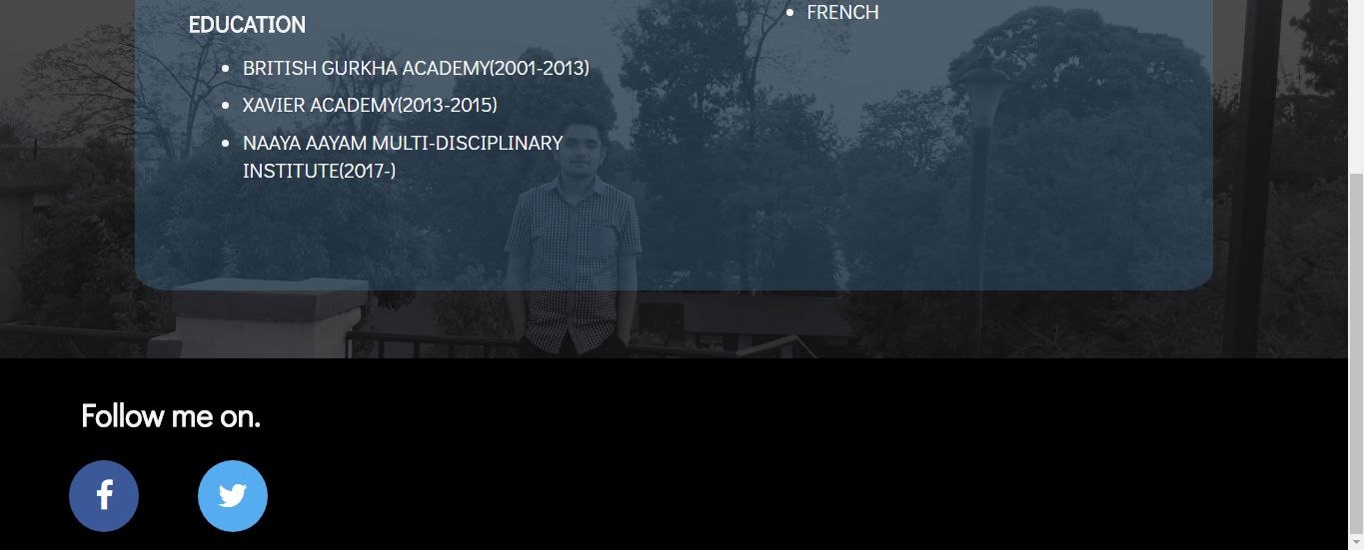

* 1. Cv page(responsive)

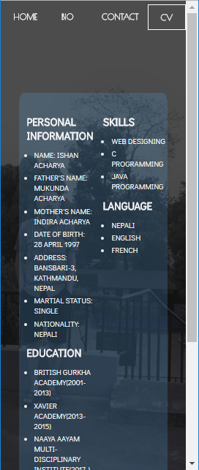

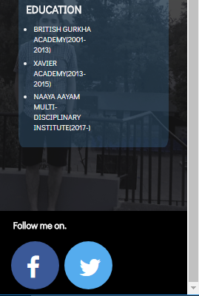

1. Working progress

In the beginning I didn’t have an attractive design for my webpage so I started visiting other web sites for ideas. I also visited w3schools.com for different HTML5 and CSS3 codes to make my webpage more attractive and user-friendly.

In the first week I made a homepage using only my ideas. I wasn’t happy with the homepage so I started making it more attractive and also changed the color combination. Still I didn’t think that it was good enough so in the second week I started making wireframes for my webpage which made the work easier and faster. Later in the coming weeks I started making the bio, contact and cv page and also did few modification like using Google fonts and adding new features in the Webpage making it more beautiful.

Home page of first week

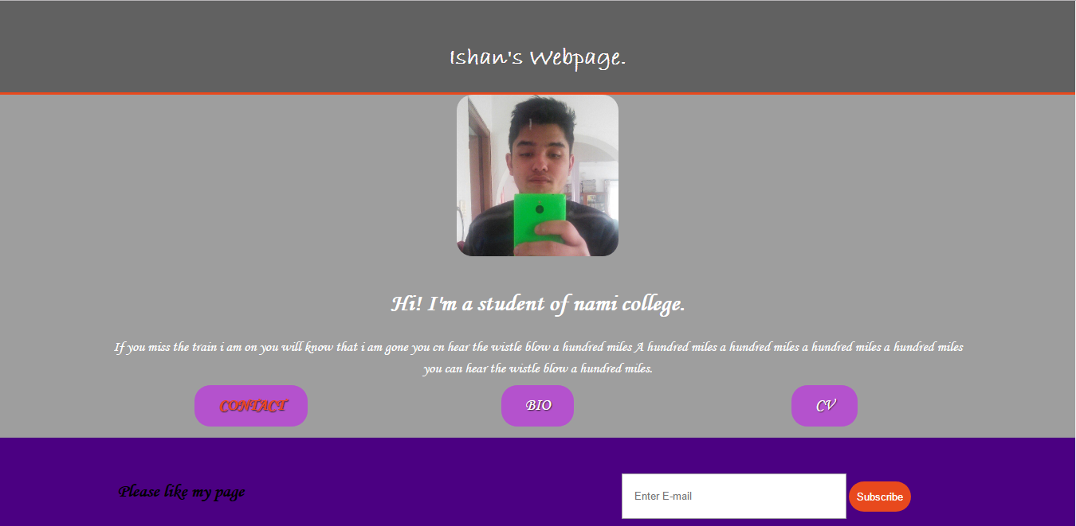

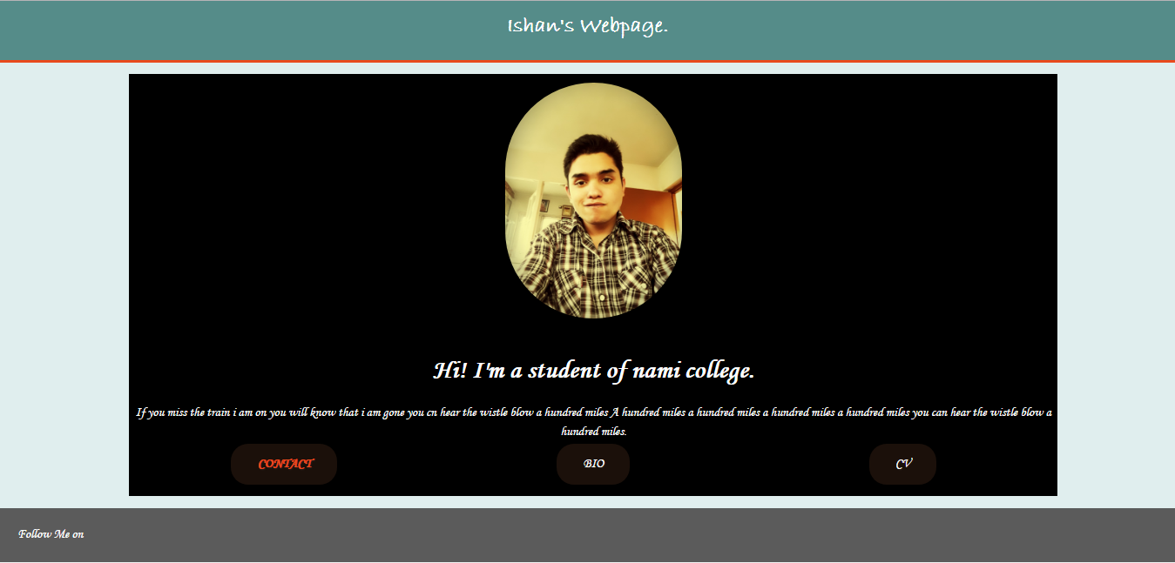

Homepage in second week

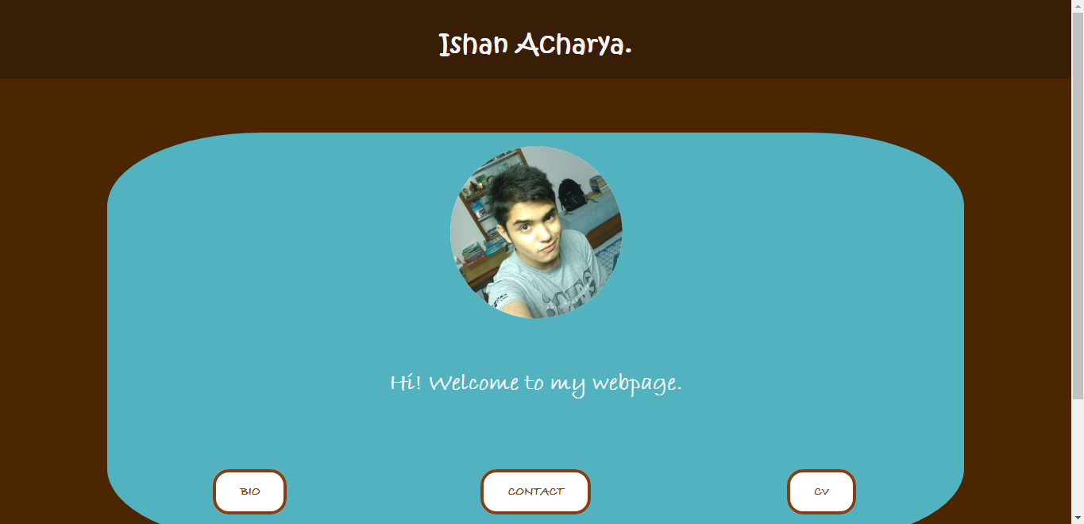

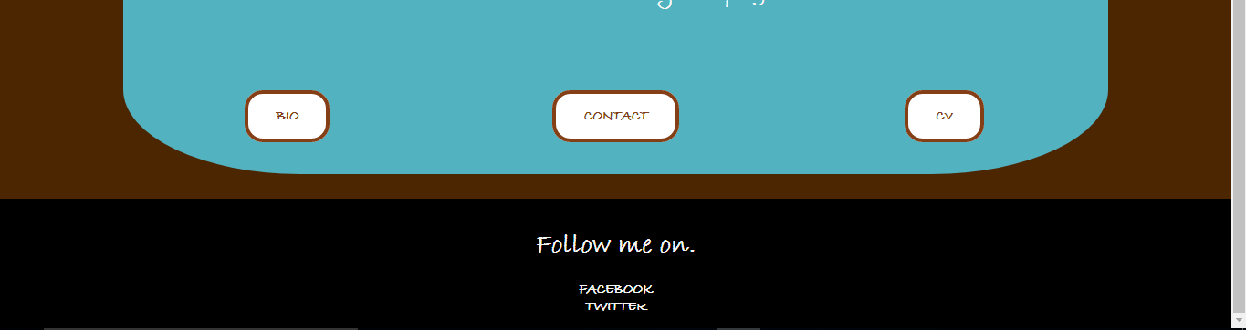

1. Good practice
   1. Speed test

As speed is one of the most important parts of internet, it is one of the good practice for web design. I have tested my website in pingdom.com as I wanted to make sure that my website does not 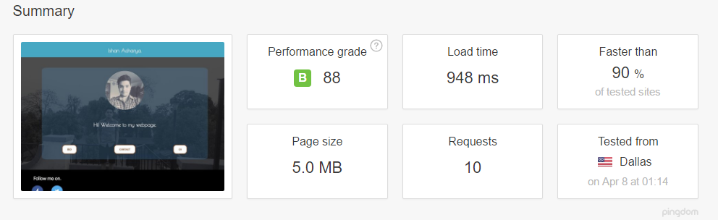take much time to load. As you can see in the picture below, the load time of my website is 948ms, it is faster than 90% and the performance grade is 88(B)

* 1. Social link

I have kept facebook and twitter as social links in my webpage in the footer section so that the visitors of my website can contact me through the social networking sites too which is a good practice for web design.

* 1. Validation test

As you can see in the picture below I have tested my website for validation and no there is no error present in it.

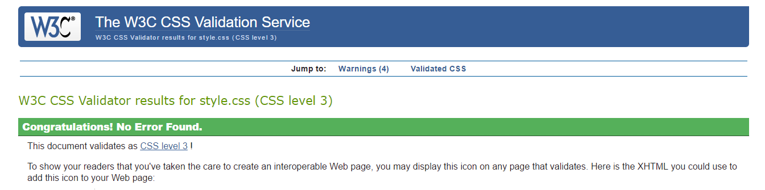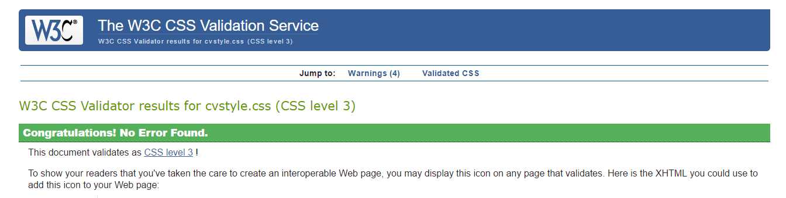

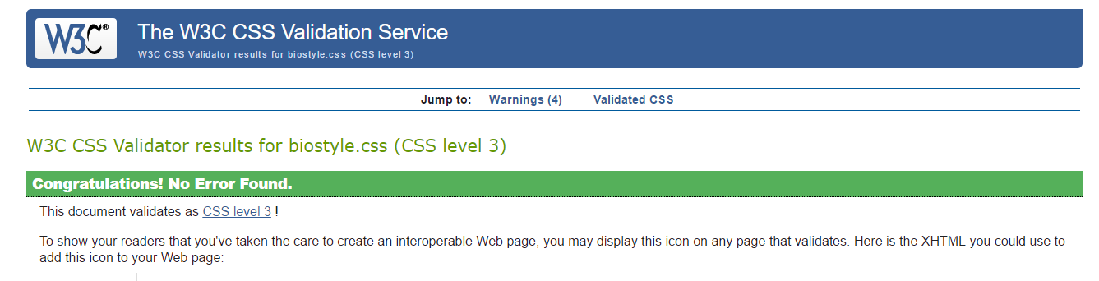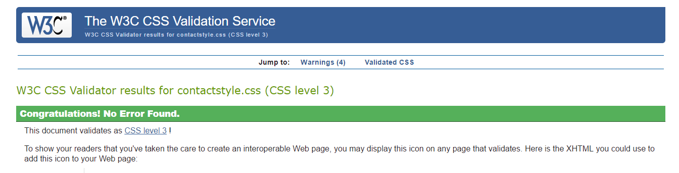

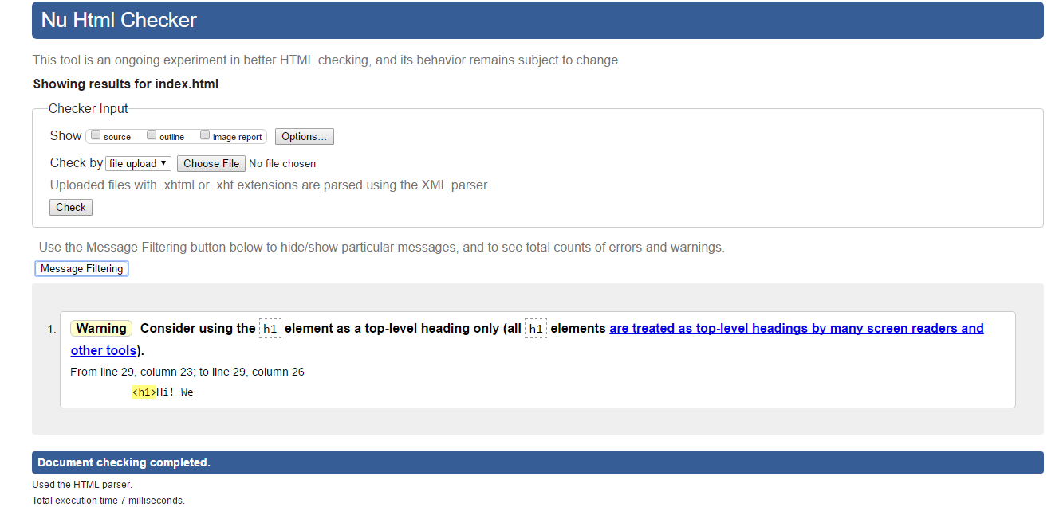

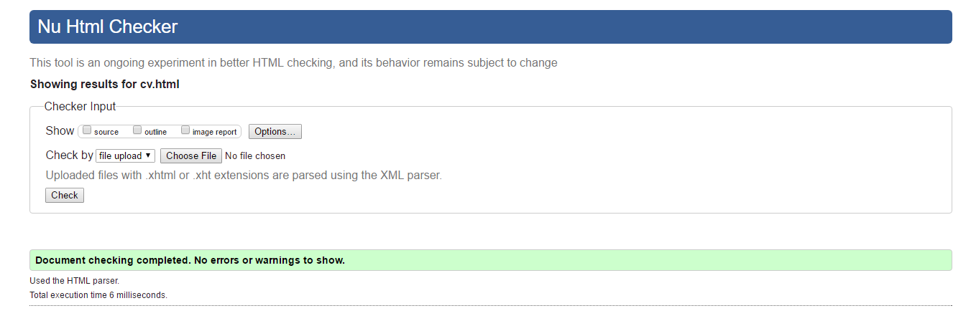

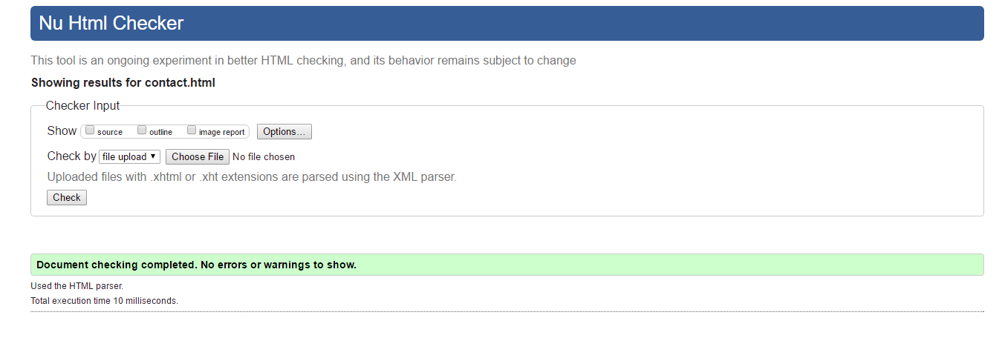

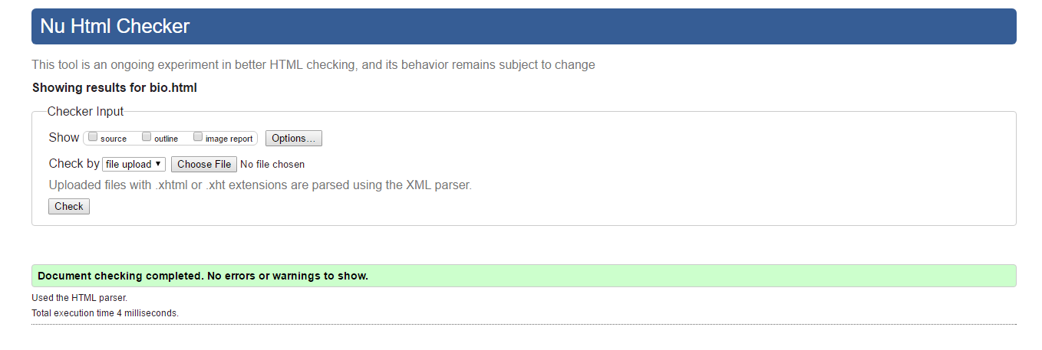

1. Conclusion

From this assignment I learnt many codes for HTML and CSS. I also got many ideas to design a webpage and the ways to make it more attractive and user-friendly. By doing this assignment I got confidence to design webpage which will help me to design more websites in the coming future.

1. References

W3schools.com, 2014, Social Media Buttons, [ONLINE] Available at: <https://www.w3schools.com/howto/howto_css_social_media_buttons.asp> [Accessed 6th April 2017].

Google Fonts. 2017. Poirent One. [ONLINE] Available at: <https://fonts.google.com/?query=poi&selection.family=Poiret+One> [Accessed 5th April 2017].

Google Fonts, 2017, Didact Gothic, [ONLINE], Available at: <https://fonts.google.com/?query=dida&selection.family=Didact+Gothic> [Accessed 5th April 2017].

Pingdom, 2017, Website Speed Test, [ONLINE] Available at: <https://tools.pingdom.com/> [Accessed 8th April 2017].

Supporting Documentation, 2016, Supporting Documentation, [ONLINE] Available at: <https://nile.northampton.ac.uk/webapps/blackboard/execute/content/file?cmd=view&content_id=_3320137_1&course_id=_64602_1> [Accessed 8th April 2017].